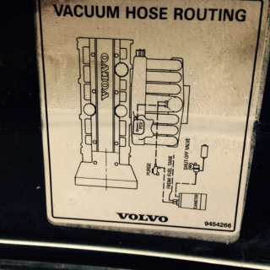

What is the function of the following:
PCV, Purge, Canister and the Shut-off-valve
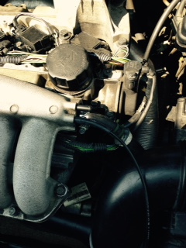 I put a cap on this port, but nothing changed. I used propane trying to find leaks. The only time the RPM’s went up was when took cap off again and sprayed propane in this port.

